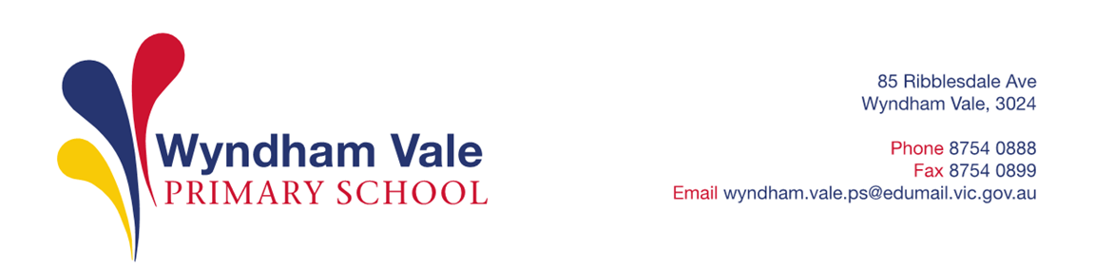

Thursday, November 2, 2023

Dear parents/guardians/carers,

Wyndham Vale Primary School (WVPS) is looking forward to another great year of teaching and learning and would like to advise you of WVPS’s voluntary financial contributions for 2024.
Schools provide students with free instruction to fulfil the standard Victorian curriculum and we want to assure you that all contributions are voluntary. Nevertheless, the ongoing support of our families ensures that our school can offer the best possible education and support for our students. We want to thank you for all your support, whether that’s through fundraising or volunteering your time. This has made a huge difference to our school and the programs we can offer. Please note that we were able to keep the curriculum contribution fees the same as 2023 at $180.
Within our school this support has allowed us to purchase student supplies in bulk which results in a significant cost saving; assist with the purchasing of art, music and physical education resources which support staff to run exemplary programs; continue to upgrade and enhance our book stock for student use; and fund celebrations such as Harmony Day as well as our numerous lunchtime clubs. We are also able to subsidise many of our camps and excursions as well as the swimming program to make them more accessible to families. All of these programs run alongside our traditional classroom teaching and learning program and are imperative as they enable us to provide an effectively balanced and rigorous overall educational experience for your son or daughter.
We invite you to support our school financially, so that we can continue to provide these opportunities for all students, by making a Curriculum Contribution. These contributions were previously known as essential student materials levy. We thank you in advance for your support.
For further information on the Department’s Parent Payments Policy please see a one-page overview attached.

Yours sincerely,

Sue Seneviratne Sharon Gatt
Principal School Council President

Curriculum Contributions - items and activities that students use, or participate in, to access the Curriculum  SUGGESTED CONTRIBUTION PER CHILD | Amount
Classroom consumables  - Art – paint, crayons, canvas, glitter, coloured paper, glue, card, wool, material  - Science – ingredients, books, shared classroom materials  - Mathematics – numeracy blocks, calculators, stationery, maths kits  - English – book boxes, reading satchels, class sets, novels, take home books  - Classroom – writing implements (pens, pencils, textas), glue sticks, writing, graph and scrap books, highlighters, post-it notes, display books, scissors, rulers, sharpeners, erasers  - Sports – equipment, ribbons, materials  - Performing Arts – costumes, instruments, books, music, pens and markers  - Library – books and subscriptions | $120
Online Subscriptions  - Essential Assessments  - COMPASS | $12
ICT and STEM  - provision of devices from the shared classroom sets  - STEM equipment | $20
Printing and photocopying of worksheets and learning materials | $13
Whole school events  - Athletics carnivals  - Harmony Day  - Lunch time clubs  - Foundation 100 days of school, Spelling Bee, Amazing Race etc | $15
Total amount | $180
Tax deductible contributions
Building fund. A tax-deductible contribution to support renovations, upgrades, and maintenance of school infrastructure. (Please indicate as appropriate) | ☐ $10  ☐ $20  ☐ Other: $___
Library fund. A tax-deductible contribution to support book purchases and other equipment that sustain the library as a valuable resource. | ☐ $10  ☐ $20  ☐ Other: $___
Total Amount | $

Extra-Curricular Items and Activities – provided on a user-pays basis
Wyndham Vale Primary School offers a range of items and activities that enhance or broaden the schooling experience of students and are above and beyond what the school provides in order to deliver the Curriculum. The cost of extra-curricular items and activities will be advised throughout the year.

Extra-Curricular Items and Activities | Amount
School magazine/ yearbook | $TBA
Optional Year 6 school camp | $TBA
Optional Year 6 Interschool Sports program | $TBA
Optional Year 4 school camp | $TBA
Optional Year 2 sleepover | $TBA
Year 3/4 athletics Carnival | $TBA
Year 5/6 Athletics Carnival | $TBA
Other optional incursions and excursions to be scheduled throughout the year | $TBA

Financial Support for Families
Wyndham Vale Primary School understands that some families may experience financial difficulty and offers a range of support options, including:
- the Camps, Sports and Excursions Fund
- Individual Payment Plans for extra curriculum items or activities
- State School’s Relief
For a confidential discussion about accessing these services, or if you would like to discuss alternative payment arrangements, contact:
Sue Seneviratne
Ph: 03 8754 0888 | Email: Wyndham.vale.ps@education.vic.gov.au Mark CONFIDENTIAL in the subject line.

Total
Category
Curriculum Contributions | $
Tax Deductible Contributions | $
Extra-Curricular Items and Activities | $
Total | $

Payment methods

Cash to the front office
- EFTPOS (in person or via phone)
- Direct debit from your debit or credit card
- Via COMPASS – money will be allocated to your child’s account

I authorise $___________________________ to be charged to my Visa /Mastercard.

Details as follows:

Student Name(s): __________________________________________________ class(es): _____________________

NAME (as on card):
Card number:
Signature |  |  |  |  |  |  |  |  |  |  |  |  |  |  |  |  | CVC:
Please indicate card type |  |  |  |  | VISA |  |  |  |  |  | MASTERCARD |  |  |  |  |  | Expiry Date |  |  |  | ______ /_______

Refunds

Parent requests for refunds are subject to the discretion of the school and made on a case-by-case basis. Refunds will be provided where the school deems it is reasonable and fair to do so, taking into consideration whether a cost has been incurred, the Department’s Parent Payment Policy and Guidance, Financial Help for Families Policy and any other relevant information.

PARENT PAYMENTS POLICY
ONE PAGE OVERVIEW
FREE INSTRUCTION
- Schools provide students with free instruction and ensure students have free access to all items, activities and services that are used by the school to fulfil the standard curriculum requirements in Victorian Curriculum F-10, VCE and VCAL.
- Schools may invite parents to make a financial contribution to support the school.

PARENT PAYMENT REQUESTS
Schools can request contributions from parents under three categories:
Curriculum Contributions  Voluntary financial contributions for curriculum items and activities which the school deems necessary for students to learn the Curriculum. | Other  Contributions  Voluntary financial contributions for non-curriculum items and activities that relate to the school’s functions and objectives. | Extra-Curricular Items and Activities  Items and activities that enhance or broaden the schooling experience of students and are above and beyond what the school provides for free to deliver the Curriculum. These are provided on a user-pays basis.
- Schools may also invite parents to supply or purchase educational items to use and own (e.g. textbooks, stationery, digital devices).

FINANCIAL HELP FOR FAMILIES
- Schools put in place financial hardship arrangements to support families who cannot pay for items or activities so that their child doesn’t miss out.
- Schools have a nominated parent payment contact person(s) that parents can have a confidential discussion with regarding financial hardship arrangements.

SCHOOL PROCESSES
- Schools must obtain school council approval for their parent payment arrangements and publish all requests and communications for each year level on their school website for transparency.

